Hackathon 3 - Day 4

# Marketplace Technical Foundation Marketplace Technical Foundation - [Nike] By: Touqeer Ahmed

Roll Number: 306062

# Product Listing:

The product listing feature is built using Next.js and integrated with an API to dynamically fetch and display products. It ensures a seamless and efficient browsing experience by retrieving real-time product data, including images, de prices, and add to cart functionality. With optimized performance and responsive design, users can easily explore a wide range of products, making the shopping experience smooth and engaging.

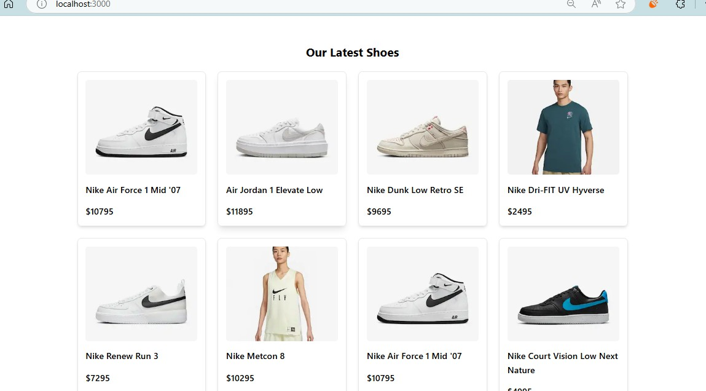

## Product Description:

The product description section is designed to provide users with detailed information about each item. Built using **Next.js** and integrated with an API, it dynamically fetches product details, including specifications, pricing, availability, and high-quality images. This ensures that customers have all the necessary information to make informed purchasing decisions. The responsive and

user-friendly layout enhances readability, improving the overall shopping experience.

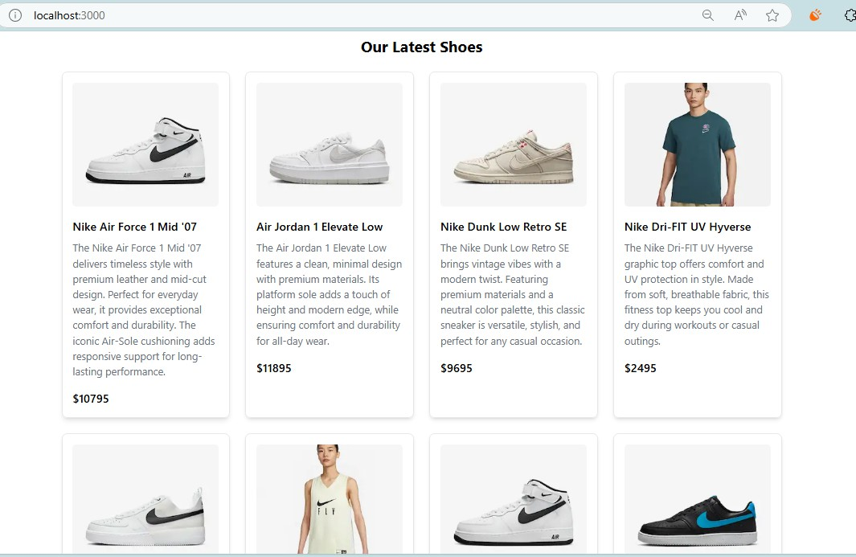

## Add to Cart Button:

The **Add to Cart** button is implemented using **Next.js** and efficiently manages the shopping cart functionality. When a user clicks the button, the selected product is added to the cart using local storage or a backend API, ensuring a smooth and responsive shopping experience. The feature includes real-time quantity updates, preventing duplicate entries and maintaining inventory accuracy. With an intuitive design and instant feedback, such as success messages, users can easily manage their cart before proceeding to checkout.

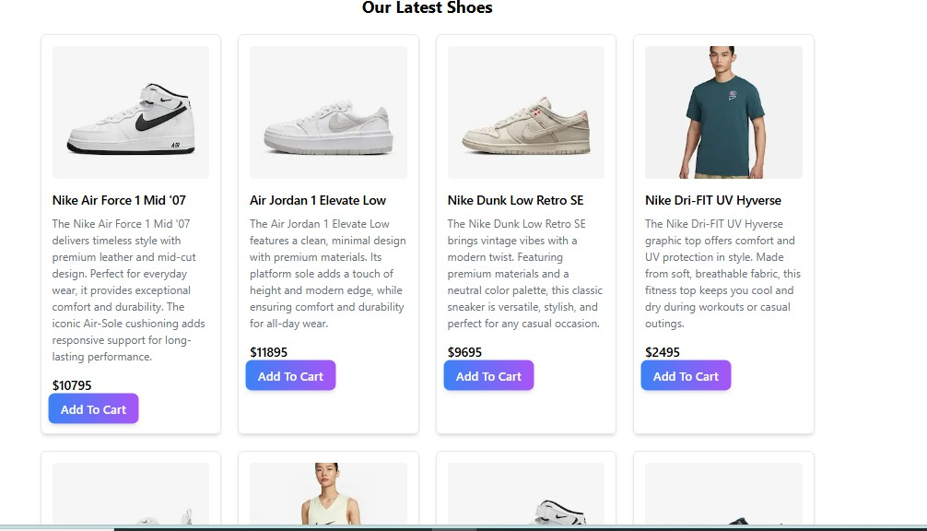

Remove Items:

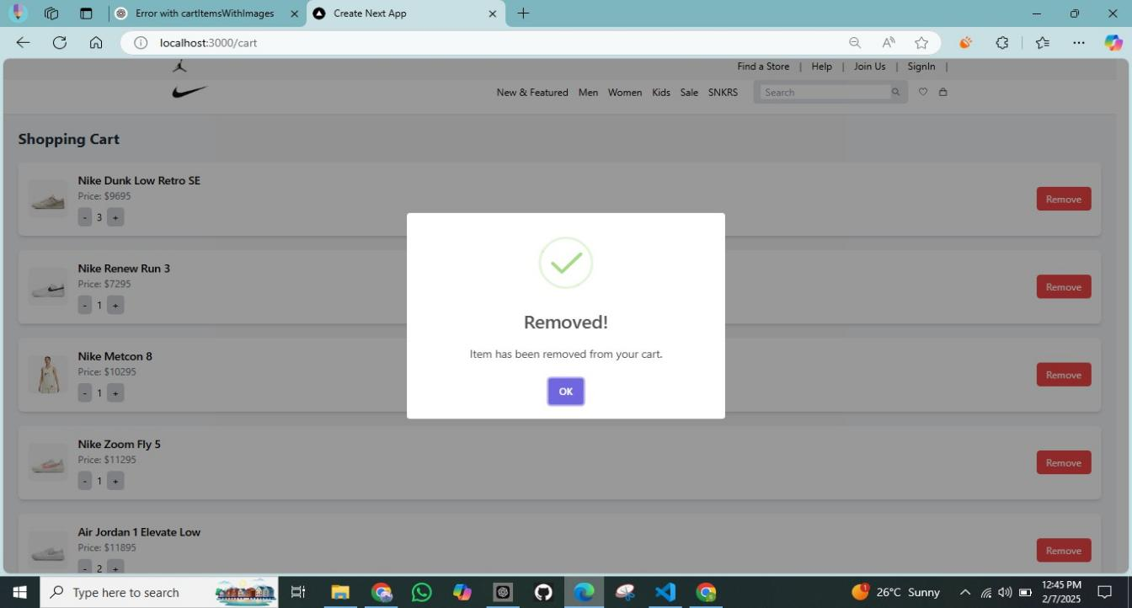

Processing Order:

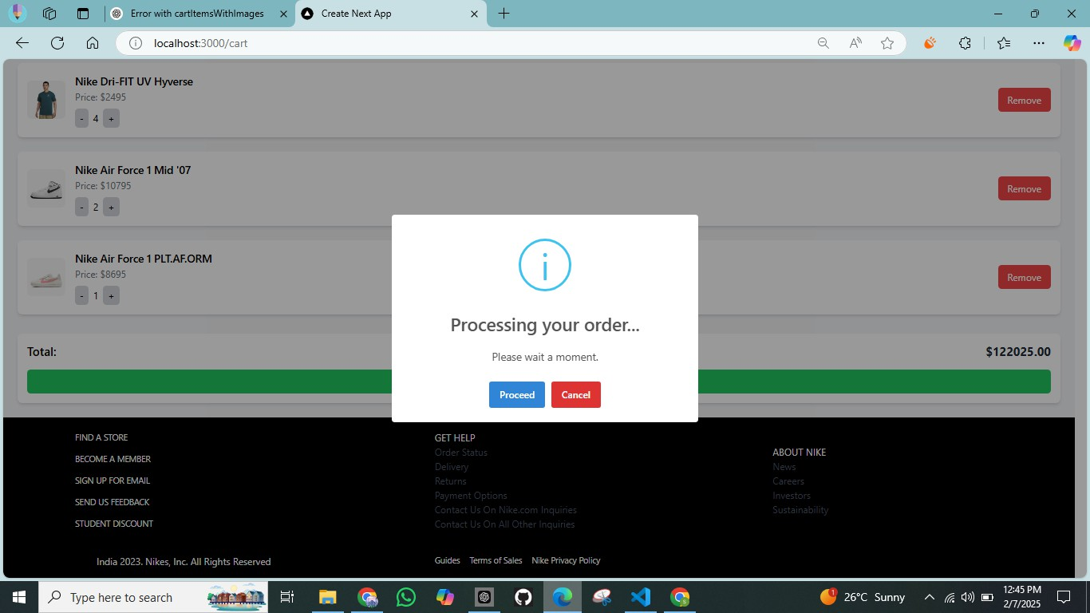

Order Success:

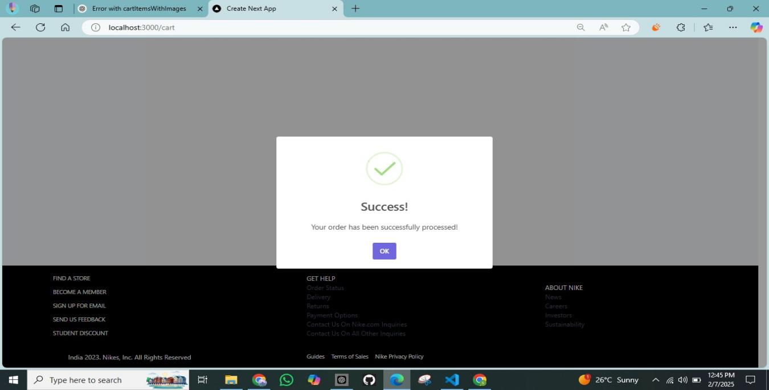

User Information:

